**ICSE SEMESTER 2 EXAMINATION   
PRACTICE QUESTION PAPER 1  
BIOLOGY**

**(SCIENCE PAPER 3 )**

*Maximum Marks: 40*

*Time allowed: One and a half hours*

*Answers to this Paper must be written on the paper provided separately.*

*You will not be allowed to write during the first 10 minutes.*

*This time is to be spent in reading the question paper.*

*The time given at the head of this Paper is the time allowed for writing the answers.*

*Attempt* ***all*** *questions from* ***Section A*** *and* ***any three*** *questions from* ***Section B****.*

*The intended marks for questions or parts of questions are given in brackets [ ].*

**SECTION A***(Attempt* ***all*** *questions*)

**Question 1**

Name the following by choosing the correct answers to the questions from the given options. (Do not copy the question, Write the correct answer only.) [10]

1. The vein that carries oxygenated blood.
2. Hepatic vein
3. Pulmonary vein
4. Renal vein
5. Sub clavian vein
6. The part of the brain that carries impulses from one hemisphere of the cerebellum to the other.
7. Medulla oblongata
8. Pons varolii
9. Corpus callosum
10. Optic chiasma
11. The bony socket in which the eye is well protected,
12. Cranium
13. Skull
14. Orbit
15. Mandible
16. Which one of the following is not a conditioned reflex
17. Writing
18. Walking
19. Blinking
20. Reading
21. The process by which the kidney regulates the salt and water content of the blood.
22. Excretion
23. ultrafiltration
24. Osmoregulation
25. Homeostasis
26. An organic constituent of normal urine
27. Ammonia
28. Urea
29. Glucose
30. Calcium
31. The number of cranial nerves in humans:
32. 12 pairs
33. 22 pairs
34. 31 pairs
35. 8 pairs
36. The disease caused by the deficiency of iodine in the body
37. Myxedema
38. Anemia
39. Simple goitre
40. Diabetes
41. The part of the brain concerned with balance and posture:
42. Cerebrum
43. Cerebellum
44. Pons
45. Medulla

This paper consists of **5** printed sides

1. A thin membrane covering the entire front part of the eye
2. Cornea
3. Sclera
4. Conjunctiva
5. Choroid

**SECTION B**

*(Attempt* ***any three*** *questions from this section)*

**Question 2**

1. Explain the difference between Diabetes mellitus and Diabetes insipidus on the basis of their cause. [2]
2. Give the location of lymph. What is its function? [2]
3. Given below is the diagram of human heart. Label the parts numbered 1,2 and3.

[3]

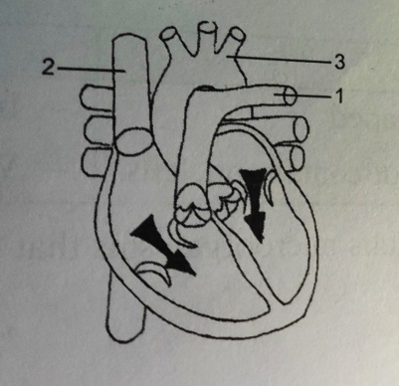

1. Name the three coats of the eyeball. [3]

**Question 3**

1. Mention two structural differences between RBC and WBC. [2]
2. Where is chordae tendinae located? What is its function? [2]
3. Here is the diagram of a nephron of the kidney. Study the same and answer the questions that follow:

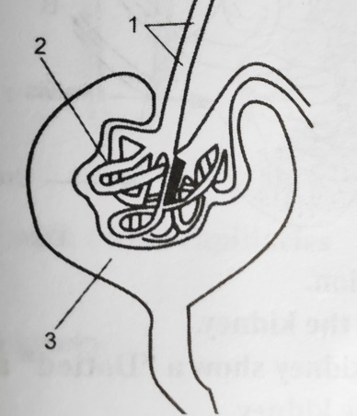

1. Name the region in the kidney where the given structure is present.

Label the parts 1,2 and 3. [2]

1. What is the collective term used for 2 and 3? [1]
2. Name and define the process that occurs in the glomerulus. [3]

**Question 4**

1. What is blood clotting?

Name the soluble protein present in blood plasma responsible for clotting. [2]

1. Give the exact location of Pituitary gland.

Why is it called the master gland? [2]

1. Give the functions of the following hormones. [3]
2. Thyroxine
3. Adrenaline
4. Insulin
5. What causes the heart sounds ‘LUBB’ and ‘DUP’?

Name the blood vessels that supply oxygenated blood to the heart muscles. [3]

**Question 5**

1. How are neurons arranged ion the cerebrum of the brain? [2]
2. Injury to medulla oblongata results in sudden death. Explain giving suitable reasons. [2]
3. Given below is the diagram of human ear . Study the same and answer the questions that follow: [3]

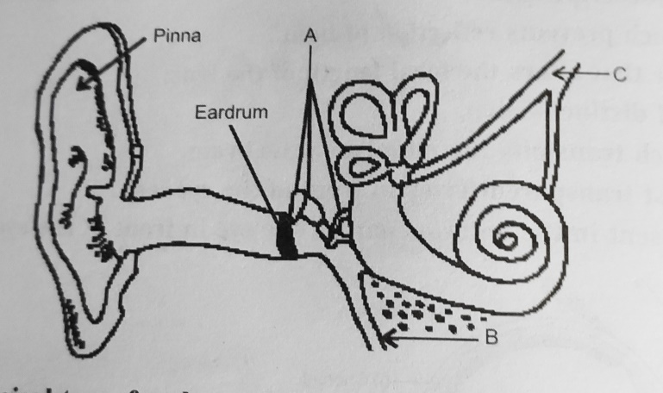

1. Give the biological term for part labeled 'A’ and state its function.
2. Name the part labeled ‘B’ and state its function .
3. Name the part labeled ‘C’ and state its function.
4. What are tropic hormones? Name any two tropic hormones . [3]

**Question 6**

1. What is the location of [2]
2. fovea centralis
3. organ of corti
4. Name the condition that results when there is [2]
5. Deficiency of Vasopressin in the body
6. Hypersecretion of growth hormone in a human adult .
7. How is hypermetropia caused? How can this be corrected? [3]
8. Complete the following table by filling in the blanks: [3]

|  |  |  |
| --- | --- | --- |
| GLAND | HORMONE SECRETED | FUNCTION |
| pancreas | (a)______________ | Stimulates breakdown of glycogen |
| Thyroid | THYROXINE | (b)___________ |
| (c )________________ | Oxytocin | Stimulates uterine contraction |